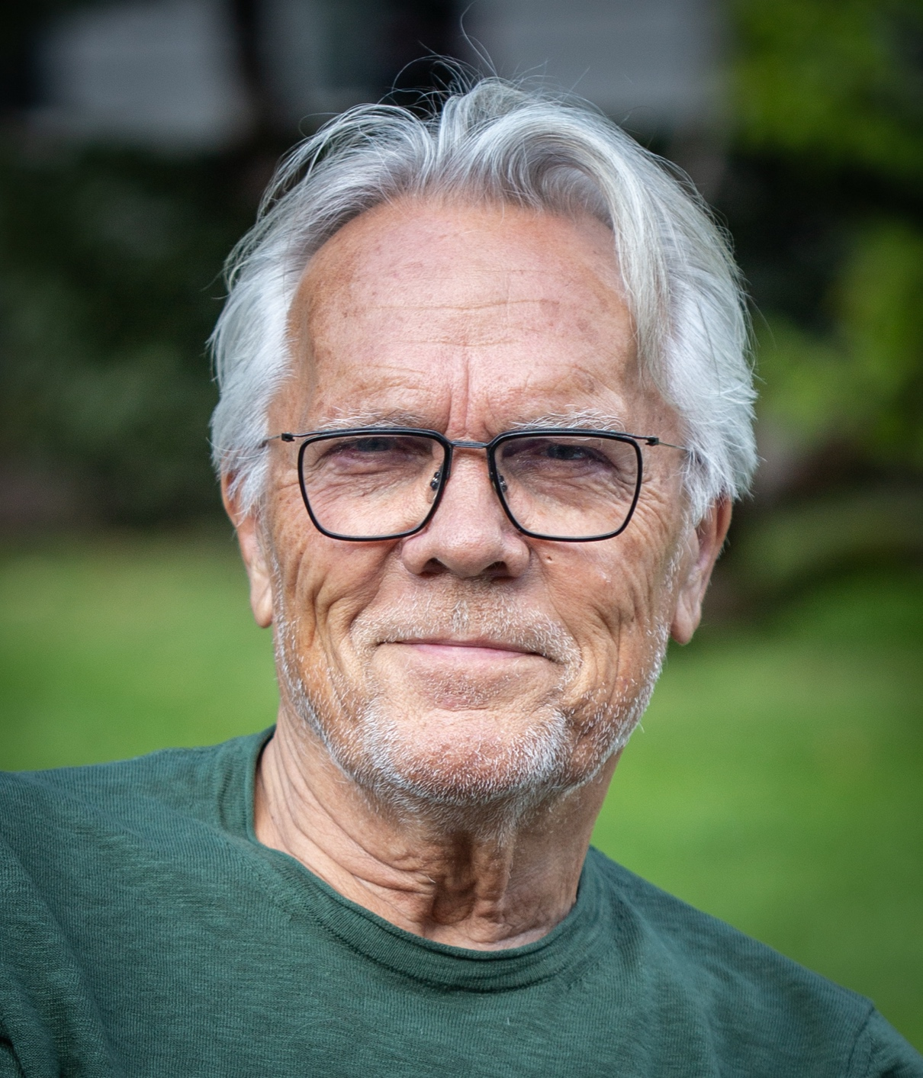

Interview with Sturla Bjerkaker:

Arne
Sturla, you are known to be a network builder and have emphasised the role of civil society and popular education in fostering democracy and participation.
What do you consider to be your biggest achievements in Adult Education?
Sturla
What is an achievement? How can a contribution be measured? As far as I know, nobody has ever done a survey to value any achievement I have made. So, it must be subjective, based on – maybe – what I hope and what I think have been big achievements…
That said, I must dig into my memories, which is the case with me, to bring up a feeling, a memorable feeling, where I thought: Yes, this was well done, Sturla. In this case, you solved it satisfactorily. And then, to the next step, I must lift my memories up to the surface to recognise who else was there at my time, because rarely any contributions have been made solely, but, in the spirit of adult community education, team-based.
To contribute to the survival of the International Council of Adult Education after CONFINTEA V in Hamburg in 1997 stands as a proud memory. After the world conference in Hamburg, ICAE was down on its feet, almost bankrupt. I offered energy to put ICAE back on track. I went twice to Toronto, where the Secretarial was at that time, and collaborated with Budd Hall, Paul Belanger, and Celita Eccher to move the office to Montevideo.
When I came to Canada for the first time, I met an ICAE with – almost – a broken neck. All resources and money were used in Hamburg. The board was not really functioning. The Secretary General was weak, and there was hardly any money for the wages of the staff, which still consisted of 5 – 6 persons. When they invited me for lunch, they had to share the bill between them, as there was no ICAE representation money left. …
Another purpose of going to Toronto was to visit OISE – the Ontario Institute for Studies in Education, well-renamed, and the former ICAE General Secretary, Budd Hall, who was there at that time. OISE is an important institution for the purpose of adult and continuing education in Canada and abroad. But Budd, who was there for many years, had moved to the other side of Canada, to Vancouver. Budd, realizing that ICAE, “his” organization, was about to collapse, asked me to join a Task Force to see what could be done. We had meetings online, and we had meetings in Oslo, and slowly we began to rise the ICAE again as the global voice for adult learning. Paul Belanger, who had ended his period as UIL director, became the new president of ICAE at a general assembly in Manilla and played of course a crucial role in this period. In Manilla, I was elected vice president from Europe to the Board, and from 1999 to 2016 (Montreal) I had diverse positions at the Executive Board of ICAE.
So, taking part in the survival of ICAE, stands for me as my greatest achievement in adult learning and education.
The second achievement is the co-organisation of the great ICAE world assembly in Malmö Sweden in 2011. Hundreds of delegates from most parts of the globe attended. Sir Alan Tuckett was elected the new president, succeeding Paul Belanger. I was elected as Treasurer in Malmö. During three to four days, I almost did not sleep. Every morning before the meetings, I was running in the park. I organized and led parallel seminars about Grundtvig, Nordic folk high schools, and study circles. What a week!
The third achievement is more “local”, Nordic. And this story is also about survival. The Nordic Folk Academy was set up in Gothenburg, Sweden, to be a Nordic Centre for further and continuing learning and education for folk high school teachers, study circle leaders and other staff in adult learning and education in the Nordics. I was appointed Director/Principal of this special institution, under the auspices of the Nordic Council of Ministers, in 1991, and shortly after this, the institution got into financial trouble, and the Nordic Council wanted to close it. I had negotiations with the Council, together with the chair of the Board, to get funds. We succeeded, and we – the small, but clever staff- said “Now, or never” and together we made a very good program for courses, seminars, projects and – not least – a new program for training of coming adult educators from the newly liberated Baltic countries. A program that came to be led by my colleague, friend, and successor as Director, Arne Carlsen.
Arne
Which activity has given you the most joy to do in Adult Education?
Sturla
Joy …? Well. It is a joy to succeed, isn’t it? I have been engaged with adult education most of my adult life, so something must have been funny. Yes, of course, a lot has been funny. Most joy? Yes, I have the answer: Yes, the celebration of the International Adult Learners Week in Cape Town in 2005 was an amazing event. Adult Education was celebrated by speeches, music, dancing, singing … It’s impossible to describe with words, but it was no doubt the best and funniest happening I have ever taken part in. A great performance, a great evening. We were all dancing, first on the floor, next on the stage. People of all colours together. Once in a lifetime.
I have been, and I am a practitioner; I have no academic degree above master's; I have been a bureaucrat, a manager, but I have also had much fun teaching, especially about adult learning and education as such, how adults learn, andragogy. I have written books about study circles as a democratic way of learning, both in Norwegian and English, and about Adult Learning and Education in Norway and in the Nordic countries. It is, of course, funny to see your books being referred to among adult educators around.
In 2006, I think it was, I visited Uruguay, first Montevideo, then Leon, where I stayed at Celita Eccher’s house for a few days. One day, we took the car on a long drive in the direction of the border to Brazil and visited a remote area and town called Canas. We visited the small community house, which was both a church, a school, a place for serving simple food and a meeting place especially for mothers and children, when the fathers were working on the Pampas. What a pale and strange man, I think the children thought, and the teacher asked me to say something in Norwegian. Looking at the floor made of flat stones, I recognised a formation looking like Norway on the map. I grabbed a stick and started to “teach”, pointing at the Norwegian “map” on the floor. The children’s (and mother’s) eyes were wide open. – This was really a magic moment, Celita said. – It was fun, I said. Really joy.
I had a similar funny experience in Gliwice in Poland last year, when I had to “entertain” four classes of 15-year-old pupils at the same time with only an old blackboard and chalk to help. – This was amazing, their teacher told me. Maybe you should come here to teach…
Maybe you have lost a school teacher in an adult educator like me.

